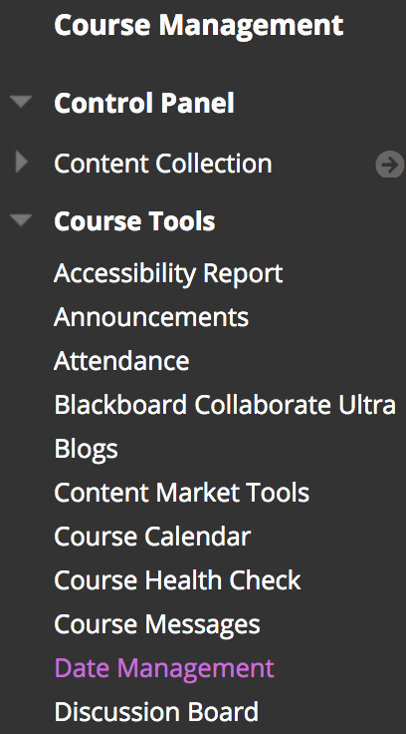
Date Management Help Guide
If you copied your course from a previous semester, you can use the Date Management tool to quickly move all of your availability start/end dates and due dates forward for the new semester.
NOTE: Date Management works for the Blackboard settings, not text that you typed into instructions or titles.
To get started: Go into your new semester's course that has the copied content and then go to the Course Management Control Panel, expand Course Tools, and select Date Management. You will see three options.

1. Use Course Start Date
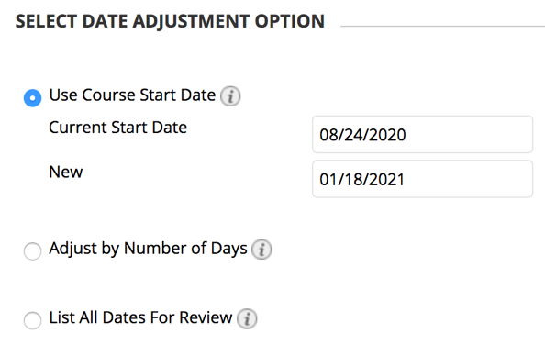
This is the recommend option since it's the easiest and quickest. It's best to do this prior to changing or adding any dates in your course.
- Set the Current Start Date as the Monday of the term start week for the dates currently in the course (i.e., the Monday of the start date of the course you copied in - if the previous term was Fall 2020, use August 24, 2020).
- Set the New Start Date as the Monday of the new term start week (i.e., if the new term is Spring 2021, use January 18, 2021).
  - NOTE: By always choosing the Monday of each week, you keep all Mondays as Mondays, all Fridays as Fridays, etc.
- Click Start.
- After it finishes processing, click Next to review all the dates. See the "List All Dates for Review" section below for more information.

2. Adjust by Number of Days
Most people don't want to calculate the number of days to shift a full semester or two, but this option can be helpful after running the "Use Course Start Date" option. For example, if your class meeting days are different, if you chose the wrong start date, or if you’re changing all due dates, you can shift all dates forward or backward (e.g., use “-3” to move them 3 days back).
- If you know how many days you need to adjust the dates, you can type in that positive or negative number in the "Shift all dates by" textbox.
- Click Start.
- After it finishes processing, click Next to review all the dates. See the "List All Dates for Review" section below for more information.

3. List All Dates for Review
This option gives you one convenient place to see and change all the start, end, and due dates currently being used in the course.
- Click Start.
- After it finished processing, click Next to review all the dates.
NOTE: The Date Management tool can only be used to view/adjust existing dates. You cannot add or remove dates from the tool.
- Default View: By default, the content will be in alphabetical order by Name.
- Type: Below the name you'll see what type it is, such as Announcement, Test, etc.
- Sort: You can re-sort everything by clicking on the column headings (e.g., click the “DUE” column heading once or twice to sort ascending or descending by due date).
- Filter: You can use the "Item Types" drop-down menu at the top to filter the type(s) of content you see (e.g., only the Announcements or only the Tests).
- Edit: Click the “Edit Dates” pencil icon to the right of each item to edit the date(s) and then click the green “Submit” checkmark on the right to save the change(s). After making a change, a yellow "Updated" note is added below it so you can quickly see which ones you've edited.
- Page Navigation: If you have more than 25 things in your course with dates, there will be multiple pages of content. At the top-right and bottom-right you'll see "Displaying 1 to 25 of X items" and "Page 1 of Y" with arrow buttons to move to the different pages.
- Refresh: If you change the dates outside the Date Management tool, you will want to click the Refresh button in the upper-right corner of Date Management to update the dates listed there. (Note the “Valid as of…” date/time by the Refresh button.)
- Adjust Dates: To shift multiple dates forward or backward, select them and click the “Adjust Dates” button at the top-left or bottom-left.

Moving from 15 Weeks to 8 Weeks
Use the Date Management tool to move all the dates forward to the correct start (see the Use Course Start Date section above) and then shift individual weeks.
- In Date Management Review, sort everything by the Start Date or Due Date.
- Then select the dates you want to move, such as all of the Week 2 dates that will become part of Week 1, by placing a checkmark in the box to the left of each one.
- Click the Adjust Dates button at the top or bottom, select the appropriate number of days (e.g., -7 days to move them back one week), and then click Go.
The old Week 3 would also need to be moved -7 days to become the new Week 2, then Week 4 is -14 days, etc.

Moving from 8 Weeks to 15 Weeks
Use the Moving from 15 Weeks to 8 Weeks instructions above but start changing dates at the end of the course instead of the beginning. For example, select the current Week 8 dates that will become Week 15 and adjust them first, followed by Week 8 dates that will become Week 14, etc.

Need Help?
Contact one of our instructional designers or view Blackboard's Date Management guide and video.

